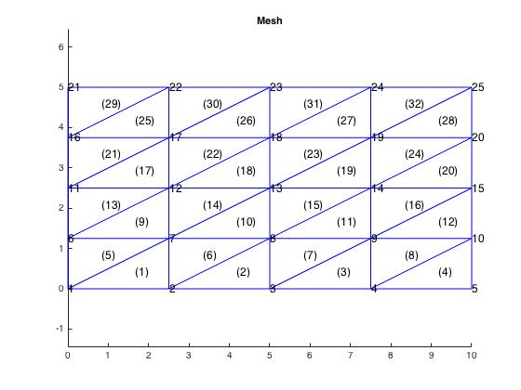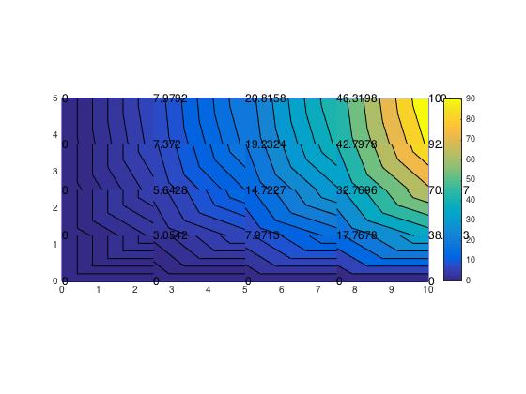

|  |  |  |  |  |
| --- | --- | --- | --- | --- |
| **MATLAB Solution** | **Exact Solution** | **% Error** |  |  |
| 0 | 0 | 0 |  |  |
| 0 | 0 | 0 | 0 | 0 |
| 0 | 0 | 0 | 2.5 | 0 |
| 0 | 0 | 0 | 5 | 0 |
| 0 | 0 | 0 | 7.5 | 0 |
| 0 | 0 | 0 | 10 | 0 |
| 3.043312437 | 2.878461232 | 5.727060138 | 0 | 1.25 |
| 7.896078607 | 7.625671821 | 3.546006076 | 2.5 | 1.25 |
| 17.60603781 | 17.32360718 | 1.630322313 | 5 | 1.25 |
| 38.6283 | 38.26834324 | 0.940612352 | 7.5 | 1.25 |
| 0 | 0 | 0 | 10 | 1.25 |
| 5.798827361 | 5.318702834 | 9.02709819 | 0 | 2.5 |
| 14.88300348 | 14.09040423 | 5.625099424 | 2.5 | 2.5 |
| 32.70279155 | 32.0098522 | 2.164768963 | 5 | 2.5 |
| 70.7107 | 70.71067812 | 3.09449E-05 | 7.5 | 2.5 |
| 0 | 0 | 0 | 10 | 2.5 |
| 8.168407207 | 6.949220144 | 17.54422853 | 0 | 3.75 |
| 20.57581815 | 18.41000033 | 11.76435511 | 2.5 | 3.75 |
| 43.96282068 | 41.8228874 | 5.116656008 | 5 | 3.75 |
| 92.388 | 92.38795325 | 5.06006E-05 | 7.5 | 3.75 |
| 0 | 0 | 0 | 10 | 3.75 |
| 10.38318692 | 7.521781682 | 38.04158857 | 0 | 5 |
| 25.57695029 | 19.92684077 | 28.35426644 | 2.5 | 5 |
| 52.16608338 | 45.26876712 | 15.23636869 | 5 | 5 |
| 100 | 100 | 1.42109E-14 | 7.5 | 5 |
|  |  |  | 10 | 5 |

**Discussion:**

We have a slight deviation from the exact solution values due to the nature of the MATLAB approximation. However, we are provided with a solution that is rather accurate, given the small error percentages we see above.